MySQL Assignment 1 – DDL Commands & Constraints
DDL Commands :
1. Table Creation

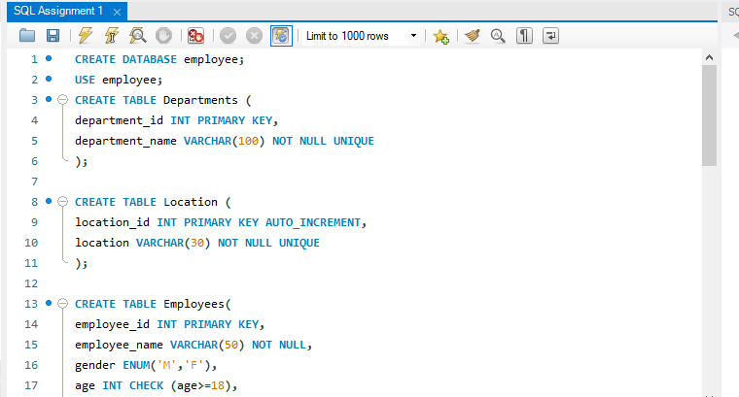
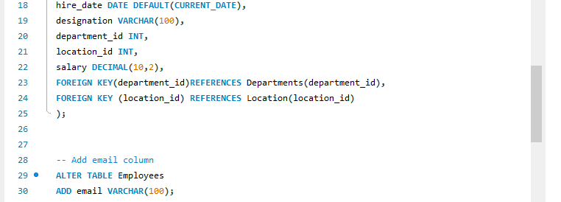
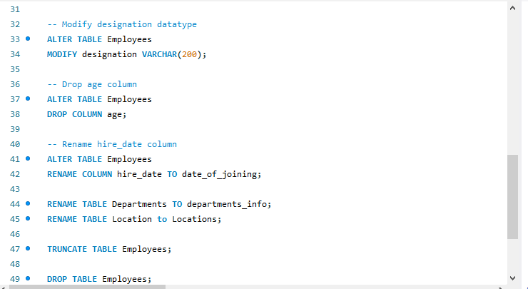
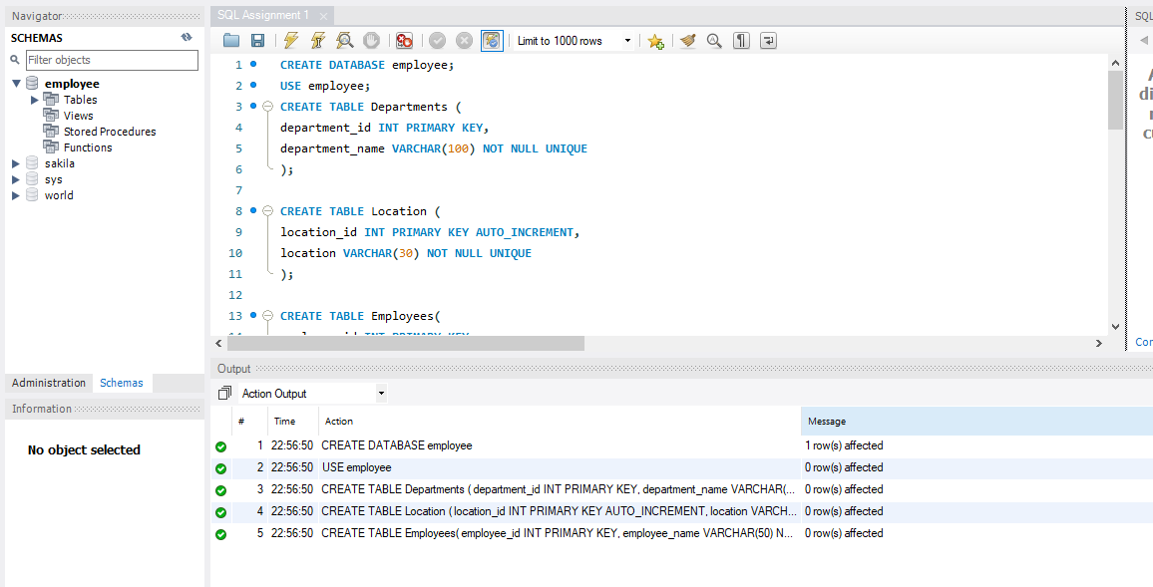

Show Tables:
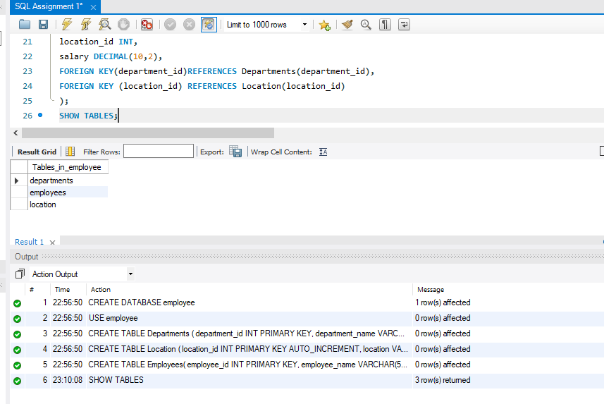

2. Table Alteration (ALTER):

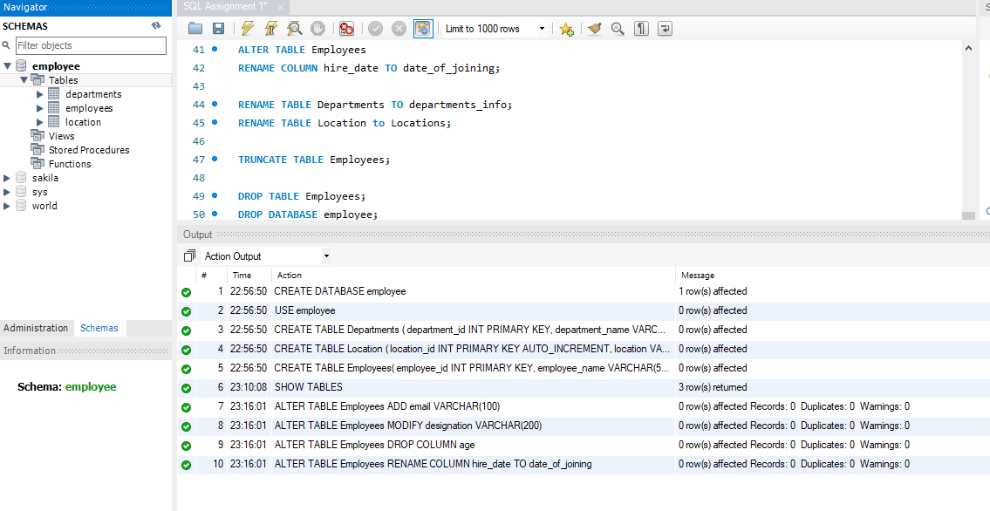

3. Table Renaming (RENAME):

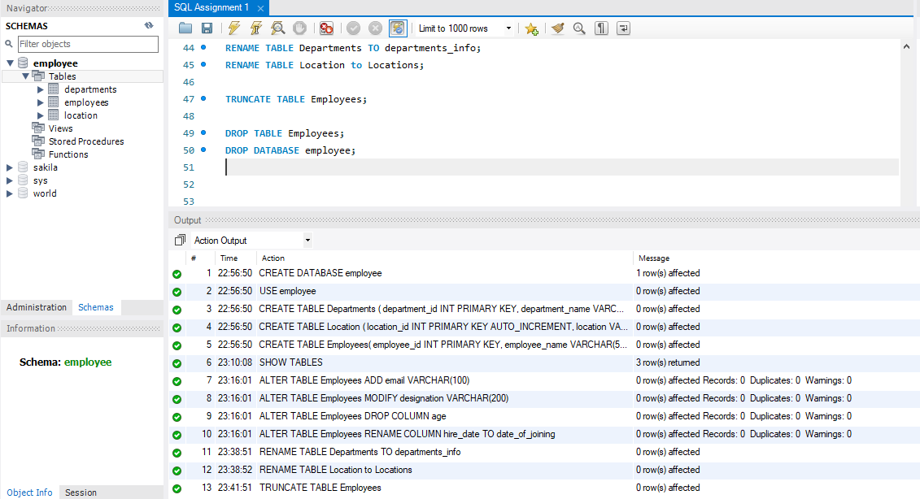

4. Table Truncation (TRUNCATE):

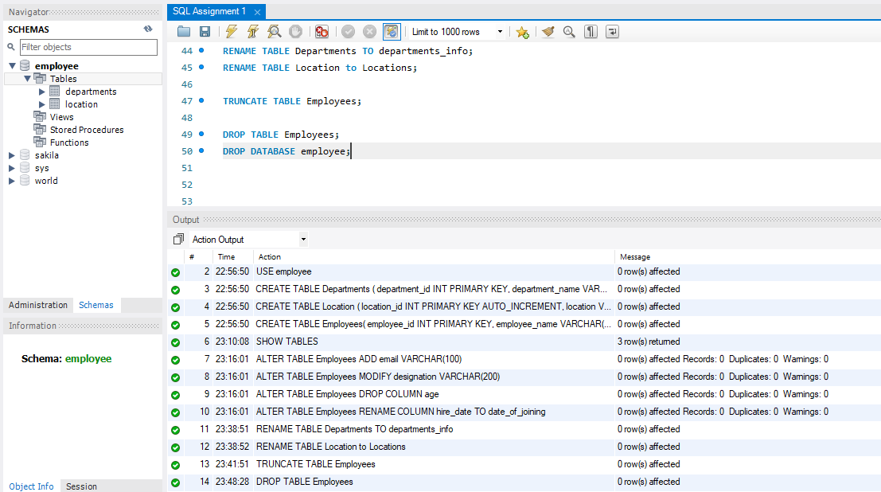

- DROP DATABASE – Typed, but not executed mam.
- REASON FOR:
- -- DROP DATABASE employee;
- -- Not executed because it would permanently delete the employee database. Mam.

